Mr. Tower’s Webquest Activity… what did we get ourselves into???
We are about to embark on a journey were you are going to have an experience of a life time. A webquest is an assignment which asks students to use the World Wide Web to learn about and/or combine their knowledge on a specific topic. It requires a blending of newly acquired and old knowledge by accomplishing a “task,” often to solve a hypothetical problem or address a real-world issue.
As the student you need to come up with a creative problem to be solved or some sort of mystery to be cracked. Topics can range from: 1) How did the Roman’s get water into cities that had zero access to nearby lakes, rivers or estuaries? 2) What did women do besides being a mother and or wife? How did a typical plebeian differ from a patrician at the end of the Roman Republic? What were the top 10 Roman gladiators of all time? When choosing to assassinate which method was most often used? Any topic that relates to ancient Rome is suitable.
Over the next two days we are primarily going to search out information and sites that help to creatively answer your question. The key is that we are going to use web links to come to what the potential answer may very well be.
Most webquests also have a "hook." This can be a treasure hunt, a game, or some other activity which is embedded in your quest. The simplest "hook" is the collection of facts and information from the various sites which make up the quest. Creative topics like: “Dancing with the Caesars” Pawn Stars: Rome something catchy.
So follow this “Road Map” to success in order to complete this project most magnificently…
Here is another Teachers example:
http://www.bootz.us/bbenoit/roman-web-quest.html Now this one is quite lame is uses just a minimal amount of websites and is really boring. You will need to incorporate some aspects of this however I’m hoping for bigger and better things from you. This is the first time I have done this so I apologize for not having a specific student example. You are all Guiney Pigs!
Day #1 – Come up with a problem, something that you are really interested in finding out information on and something that you think others will also be perplexed by.
- Here is where you write this: ______________________________________________________ Now this very well may be a starting point. What you have written above may just be the tip of the ice berg.
- You are going to create a website which either a team or individual will have the opportunity to navigate through. (You will all eventually have to complete an assigned persons webquest)
- There are going to be multiple requirements that you need to include when completing this project but you will have the ability to link them creatively to your question or interest.
- Select 5 topics that could some way are related to your question. Here are examples that you may choose from but are not limited to:

Law and Government | Strange but True | Gods | Clothing and Fashion | Empire Rise, Ride and Decline | Careers | Women’s Roles | Music | Sports | Literature
Food | Geography | Caesars | Architecture | Army | Slaves | Theater | Art | Medicine and Health | Weapons and Battle
Once you have highlighted five topics let’s move onto finding websites that may have information about these topics.
- Begin by categorizing topics and websites (Cut and Paste from above chart and your web browser)
- Here is a site that can help link you to related topics: http://www.teacheroz.com/romans.htm
- This took me all of about ten minutes to find imagine what you can do with your skills you learned from Mr. Brester!!
- Look, skim, but eventually get to work. Pick categories and move on. You may not use half of what you find but this will help to get you started in the right direction.

Day #2
- Today you will need to get more depth on your website research. Spend the day looking for specific sites that relate to your topics.
- You should have 5-7 different websites for each of your topics
- I will collect these from you at the end of the week using a shared folder (collection) on Google docs (We will cover this in day three)
- Be sure these websites are credible and specific to the topic you are researching. As you know there is a lot of useless sites that are not appropriate for school or are not connected at all to your topic.

Day #3 Arrowhead High School – A Google School
In order to get you set up correctly with our own AHS Google accounts please use the following steps:
- Go to the following URL: https://accounts.google.com/ServiceLogin?service=writely&passive=1209600&continue=https://docs.google.com/&followup=https://docs.google.com/&ltmpl=homepage
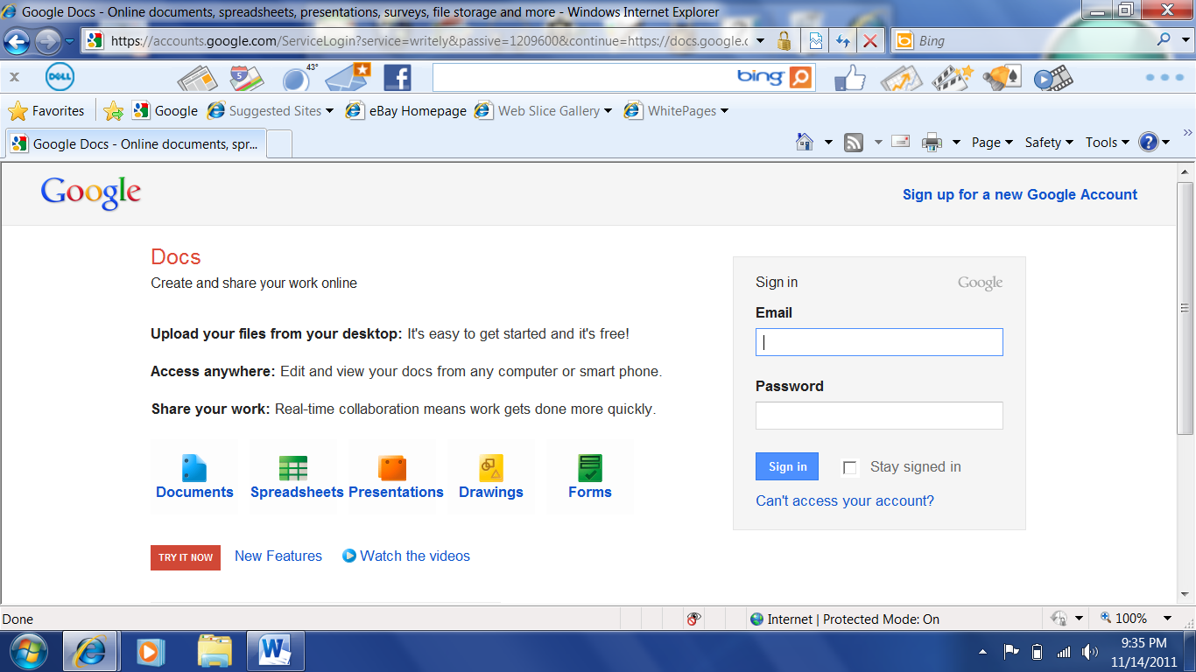
Next log in using the following email address:
- 4 lastname@arrowheadschools.org
Password:
- ID#AUHS
Capthcha
- This might be the most difficult part of this assignment
- Take our time…Who can do it on the first try? Anyone??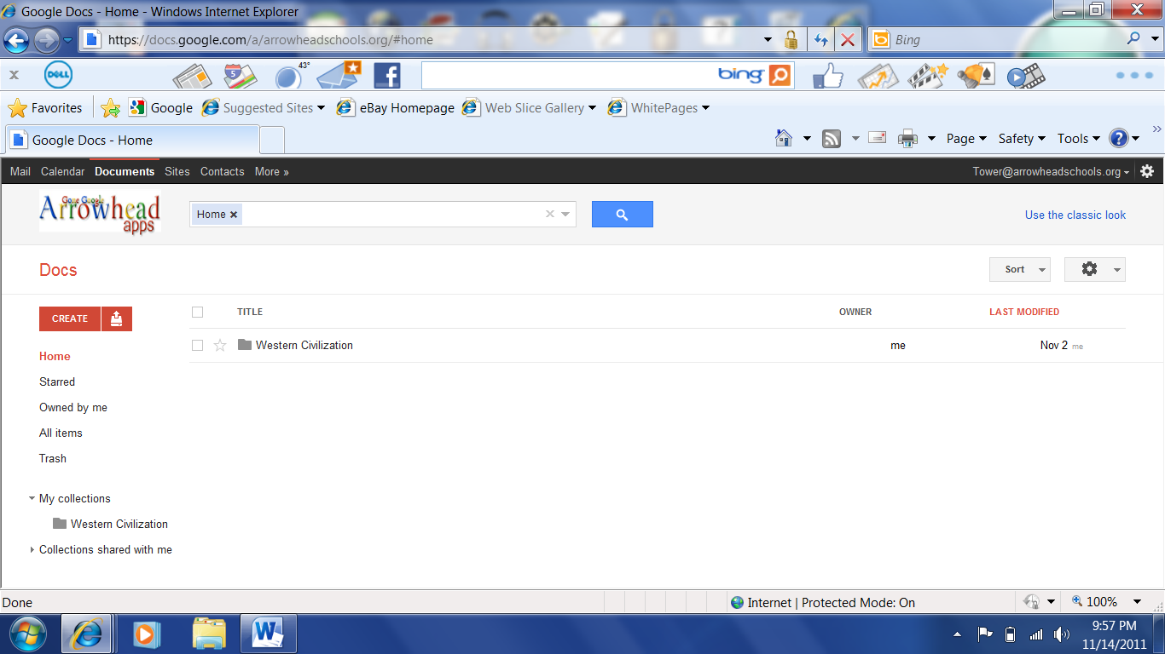
Now find the document we are using… we are on the way to good times with Google Docs.
Day #4
- We are going to be using Google Sites in order to produce a website which will be the central driving force behind our web-quest
- Today Ms. Janigo will work to explain the use and organization of Google sites
- Here you should have all of your links and explanations of how students will carry out your webquest
- So if you need them to create a cartoon using Toondoo then you need to have all websites and requirements listed here. Also be sure to note how students are going to turn in their information to Mr. Tower. IE placing a link to Toondoo in their shared folders. Or by completing your questions for one of your tasks and then placing the answers again in their shared folder.
- Today I need you to begin to brainstorm a strategy of how this all is going to fit together. Is your webquest going to be a scavenger hunt? Is it going to just be a fact finding tour? Is it going to blow my mind with its creativity?
Here is what you are going to have to include in this project:
- I want you to have Five Tasks that need to be completed for each of the above mentioned topics.
  - That could be writing a short essay. (with information gathered off of the websites you found.
  - That could be creating a collage with pictures, architecture, sculpture or any art. (this would be done electronically from website you have found)
  - That could be answering a series of questions. (Duh from websites you have found)
  - It really could be anything
  - I WILL GIVE EXTRA CREDIT TO INDIVISUALS WHO ARE HIGHLY CREATIVE AT GENERATING THESE TASKS.
  - Use the list that we generated as a class on Google Docs to come up with some creative ideas

- You will need to have one of these tasks act as a game. Hopefully you have found a site that relates to Rome in some form or fashion. There are lots of these. Here are a few that I have found:
  - http://www1.teachersfirst.com/getsource.cfm?id=8945
  - http://www1.teachersfirst.com/getsource.cfm?id=10470
  - http://www1.teachersfirst.com/getsource.cfm?id=10470

- You will finally need to provide a one page overview (typed, double spaced, 12 point font) clearly stating with evidence how you answered you own problem related to Rome or that you answer solved your mystery connected to Rome.

- You will have four more days to work on this project in class. Be sure to use these days wisely.

